

***WINTERSCAPE 2020***

***January 25, 2020***

**FEBRUARY 5,2011**

**FEBRUARY 5,2011**

Dear Winter Guard Directors,

Welcome to the Orchard Park High School’s 17th annual “Winterscape” show. We hope you have a great show! Enclosed you will find the information you will need, to participate in this year’s show. This information includes a show schedule, a map of how to get to the high school, a building layout, and other general information.

Please feel free to contact Scott Bean at (716) 997-9284 or Nicholas Boucounis at (716) 994-3323, if you have any special needs or concerns. If you have any questions on the day of the show, please call Karen Phillips (716) 432-7319. Our staff and parents are looking forward to assisting you on that day.

**GENERAL INFORMATION**

**Arrival**

You may arrive any time after 2:00 PM at the Baker Road side of the High School. See the attached map. A guide will meet your group to assist you, stamp hands, get any last minute changes to your show write-up, and help you with any questions. They are also instructed to keep you on time but ultimately this is up to you and your staff!

**Parking/Props**

Guard buses and trucks are to park in the Baker Road lot. There is a loading dock available at the far end of this lot for props, or they can be brought through the double doors at guard check-in. (The door’s center mullion is removable). An area for prop storage will be assigned to your group when you arrive. Please note: **Spectator parking will be in the Freeman Road lot only. See the attached map.**

**Food**

Food concessions will open at 2:30 PM in the Cafeteria. Thank you for supporting our booster organization!

**Dressing**

Your guard has been assigned a room in the high school, for changing into costumes. Your staff/director will be held accountable for the room and its contents. Please leave your room as you found it. We ask that there be an adult in the room whenever there are students present. Please be advised, no glitter whatsoever is allowed in the school or classrooms. If you need glitter, please apply outside or on your bus. We do not want to have to charge your guard with any custodial cleaning fee for our event!

**Warm-up**

Please see the enclosed schedule for your warm-up times and locations. Guides will assist your group in transitioning from area to area at the appropriate time.

**Tapes/Video**

Each guard may send a representative into the designated area of the bleachers to record their own guard. A video will not be provided for you. Judge’s comments will be available shortly after each guard’s performance on *Competition Suite*.

**\*\*\*Wifi Info for Show Day 🡪 Username: TBA after winter break by school, Password: TBA after winter break by school**

**Critique**

The critique will be held in the Judges Room (Room 113) after Retreat. The schedule is attached.

**Awards**

Score announcements will be made for each guard during Retreat. Guard captains should proceed to the gymnasium hallway immediately following the last performance to line up for retreat.

**Sound System**

Sound System Services provided by Arthur Graton.

**Tickets**

Tickets are available at the door for $6.00 each. Children 5 years of age and under are admitted free.

***NY State law does not allow smoking anywhere on school district property. Please remind your parents. Anyone wishing to smoke must leave school property.***

Please feel free to ask any parents or staff for assistance or if you have any questions.

**If you have any questions the day of the show, please call**

**Karen Phillips at (716) 432-7319**

**Show Schedule**

Sound checks in the gym from 3:00-3:45 PM or during intermission.

National Anthems/Introductions at 3:50 PM

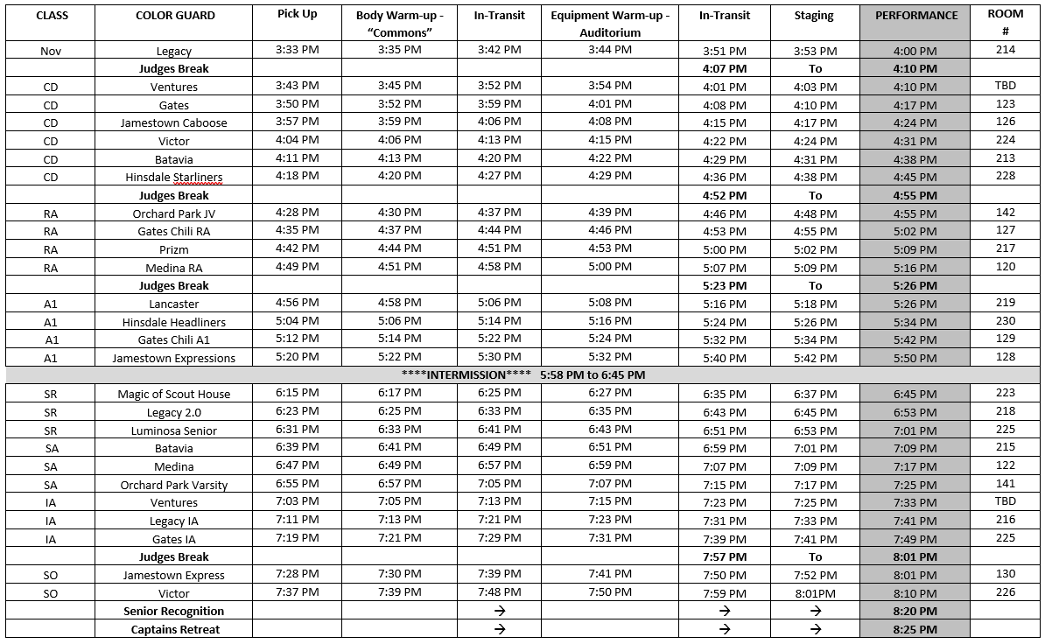

**CRITIQUE - ROOM 113**

Each guard will have 3 minutes per judging station. Table #1 will include the Equipment and Movement Judges. Table #2 will include Design Analysis, GE1, and GE2. The Timing and Penalty Judge will manage the 3-minute increments per table.

With two guards in for critique every six minutes, critique should wrap up in approximately an hour and 15 minutes. Thank you for your patience as we try to make this an effective and quick process yet still staying within the circuit rules.

Critique will begin promptly at 8:25 pm. The order is below 🡪

CRITIQUE ORDER (according to Google Maps) 🡪

Magic of Scout House – Canada

Ventures – Canada

Prizm – Canada

Legacy – Canada

Lakeside – 181 miles

Phoenix – 143 miles

Victor – 88.7 miles

Gates – 82 miles

Jamestown – 69.1 miles

Hinsdale – 61.3 miles

Medina – 50 miles

Batavia – 48 miles

Lancaster – 11.4 miles

Luminosa – Buffalo 6.8 miles

Orchard Park – 0 miles

|  |  |  |  |
| --- | --- | --- | --- |
|  | Magic of Scout House  Ventures Cadet  Ventures IA |  |  |
|  | Prizm RA  Legacy Novice |  |  |
|  | Legacy2.0  Legacy IA |  |  |
|  | Victor Cadet  Victor SO |  |  |
|  | Gates Cadet  Gates RA  Gates A1 |  |  |
|  | Gates IA |  |  |
|  | Jamestown Caboose  Jamestown Expression |  |  |
|  | Jamestown Express |  |  |
|  | Hinsdale Starliners  Hinsdale Headliners |  |  |
|  | Medina RA  Medina SA  Batavia Cadet  Batavia SA |  |  |
|  | Lancaster A1  Luminosa |  |  |
|  | Orchard Park JV  Orchard Park Varsity |  |  |
|  |  |  |  |

**GYM LAYOUT**

YOU WILL BE ENTERING THE GYM FROM THE RIGHT SIDE, AS THE JUDGES STAND/SIT. YOUR FLOOR WILL PULL FROM THE RIGHT TO THE LEFT. WHEN FINISHED PERFORMING YOU WILL PULL ACROSS THE CENTER LINE FROM RIGHT TO LEFT AND EXIT AT THE LEFT FRONT.

PLEASE FOLD YOUR FLOORS ACCORDINGLY.

Back Side Seating

Front Side Seating

Interval

Time Line

Guard

Entrance

Guard

Exit

**Directions to Orchard Park High School:**

From the North/East:

Take the NYS Thruway, Route 90, to Exit 55, Route 219 South. Go 3 miles to Orchard Park, Route 20A. Bear right coming off of the exit, into the Village of Orchard Park, heading east on Route 20A. The third traffic light is Freeman Road. Spectators should turn left onto North Freeman Road, followed by a right turn into the school. Guards should continue one street past the traffic light at Freeman Road and Route 20A, to Baker Road on the left. Turn left onto Baker Road, followed by a left turn into the school.

From the West:

Take the NYS Thruway, Route 90 to Exit 56, Milestrip Road. Turn left after the toll, onto Milestrip Road east. Stay on Milestrip Road, crossing Route 20 and then crossing Route 277 (Orchard Park Road). Guards should continue east 2 more miles to Baker Road, and turn right. The school will be on your right before you reach Route 20A. Spectators should turn right off of Milestrip Road onto Route 277, Orchard Park Road south. The first traffic light is at Webster Road. Turn left onto Webster which becomes North Freeman. Turn left into the school before you reach Route 20A

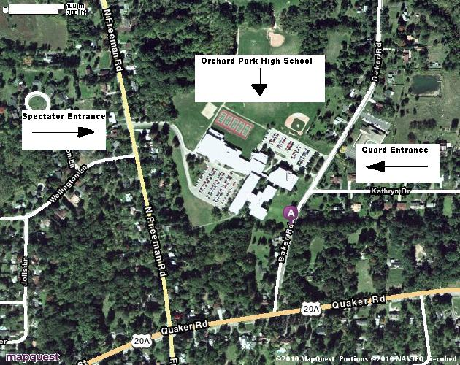

Gym

Spectator Parking

Spectator Entrance

North Freeman Road

=traffic light

Route 20A (East Quaker Street)

Guard Parking

Guard Entrance

Baker Road

=traffic direction

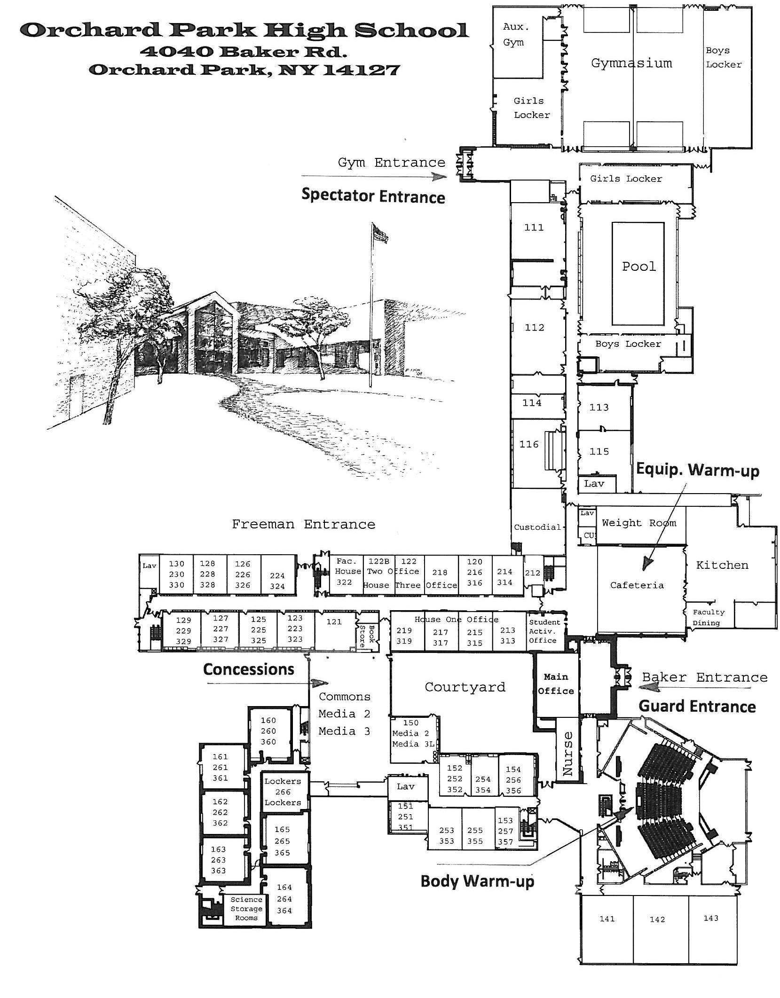

**Body warm up**

**Equipment warm up**

**Concessions**

**Concessions**